**Q.2  Create Book_type by grouping the information Bookno, Title, and Author. Create table Purchase with Pid, book_details, date, amount. Insert five records in Purchase Table.**

**SQL QUERY:**

**-- Step 1: Create or replace the Book_type user-defined type**

CREATE OR REPLACE TYPE Book_type AS OBJECT (

Bookno NUMBER,

Title VARCHAR2(100),

Author VARCHAR2(100)

);

**-- Step 2: Create the Purchase table using the Book_type type**

CREATE TABLE Purchase (

Pid NUMBER,

book_details Book_type,

purchase_date DATE,

amount NUMBER

);

**-- Step 3: Insert five records into the Purchase table**

INSERT INTO Purchase (Pid, book_details, purchase_date, amount)

VALUES (1, Book_type(101, 'Book 1', 'Author 1'), TO_DATE('2023-10-28', 'YYYY-MM-DD'), 20.00);

INSERT INTO Purchase (Pid, book_details, purchase_date, amount)

VALUES (2, Book_type(102, 'Book 2', 'Author 2'), TO_DATE('2023-10-27', 'YYYY-MM-DD'), 25.00);

INSERT INTO Purchase (Pid, book_details, purchase_date, amount)

VALUES (3, Book_type(103, 'Book 3', 'Author 3'), TO_DATE('2023-10-26', 'YYYY-MM-DD'), 30.00);

INSERT INTO Purchase (Pid, book_details, purchase_date, amount)

VALUES (4, Book_type(104, 'Book 4', 'Author 4'), TO_DATE('2023-10-25', 'YYYY-MM-DD'), 35.00);

INSERT INTO Purchase (Pid, book_details, purchase_date, amount)

VALUES (5, Book_type(105, 'Book 5', 'Author 5'), TO_DATE('2023-10-24', 'YYYY-MM-DD'), 40.00);

SELECT * FROM Purchase;

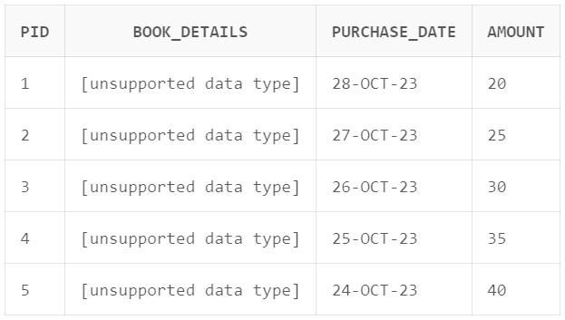

SELECT p.book_details.Title, p.book_details.Author, p.pid, p.purchase_date, p.amount

FROM Purchase p;

